Introduction to Cloud Solutions Lab Report
Use this template to document your work as you complete the lab assignment in QA.

Your Information
Your Name:
Lab Title: Deploy and Modify Azure Resource Manager Templates

Instructions
Follow the instructions to answer the questions related to the lab and add the required screenshots to the steps that ask you to take a screenshot. Submit your completed report following the instructions in Canvas.

Section 3
- Step 4: After replacing RANDOM with the 4 numbers you selected, copy the template.json file. Next, open a text editor on your local system (Notepad++, etc). and paste your template there. Save the template to your CYB260L folder that you created earlier, and rename it vm1-azure.json.
- Step 10: Take a screenshot of your web site from calabsYOUR-RANDOM-NUMBER-webapp.azurewebsites.net 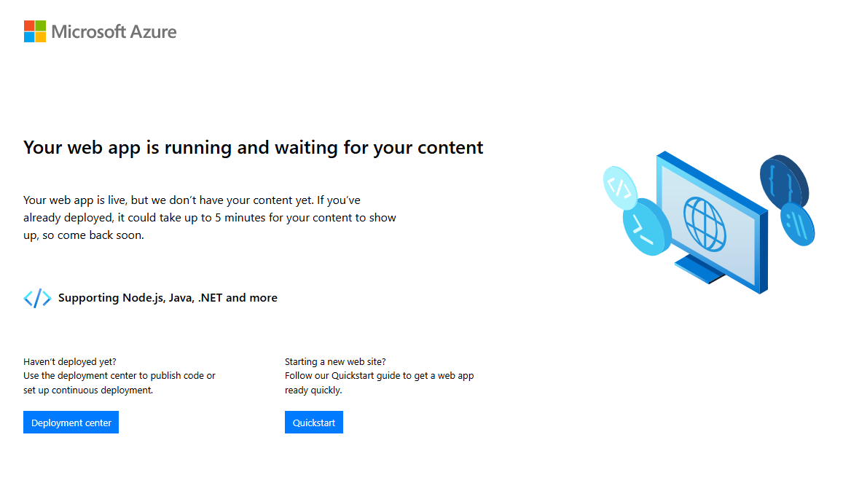

- Summary: Run the Start check validation, take a screenshot of the results.
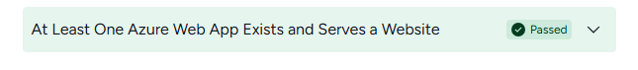

- Click Next to continue on to the next section. Proceed with the steps in QA.

Section 4
- Step 5: After replacing RANDOM with the 4 numbers you selected in the previous step, copy the revised template.json file. Next, open a text editor on your local system (Notepad++, etc). and paste your template there. Save the template to your CYB260L folder created earlier, and rename it vm2-azure.json.
- Step 10: Take a screenshot of your website from calabsYOUR-RANDOM-NUMBER-webapp.azurewebsites.net 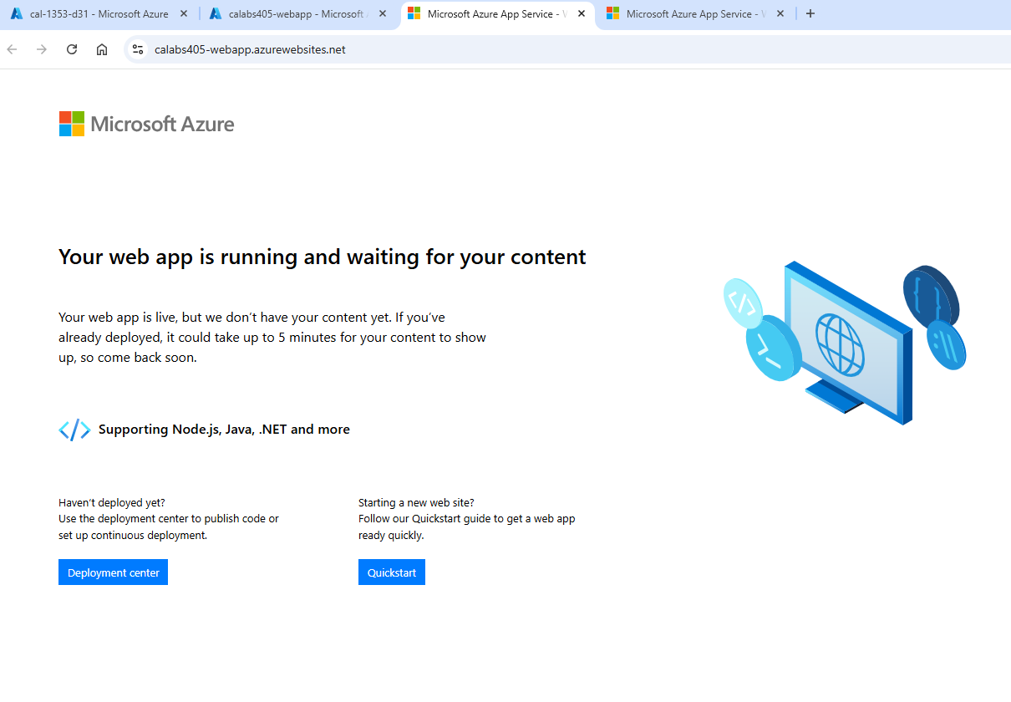

- Summary: Run the Start check validation, take a screenshot of the results.
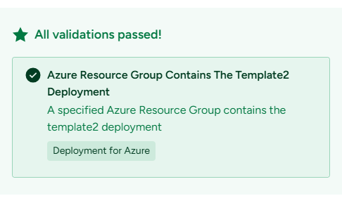
- Click Submit
- Take a screenshot of the results window displayed which includes time duration, validation checks used and total validation checks failed. 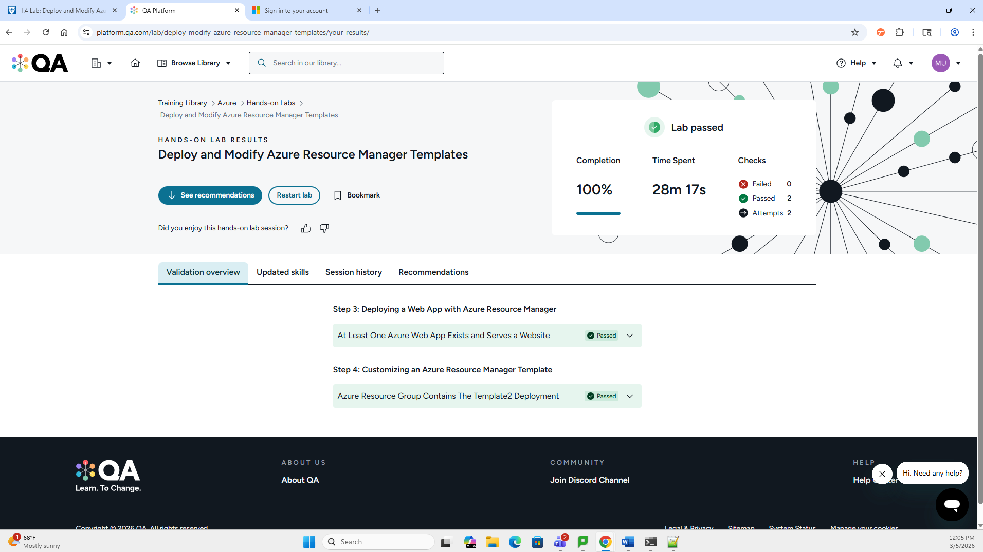

- On your local system, open the CYB260L folder and take a screenshot of the contents.
